**Melbourne Polytechnic**

**Bachelor of Information Technology**

**Capstone2Experience21 & 2**

UnityHealth

iTherapeutics Advanced Admin Tools

**Final Project Report**

**Project team:**

**Sarnvisoth NUON**

**Biraj Paudel**

**Harindu Kalupahana Yasadhara**

**Unity Health Pty Ltd**

**Peter De Lorenzo (CEO of Unity Health)**

**Nipuna Ranasinghe (Full Stack developer – UnityHealth)**

**Supervisors:**

**Dr. Sitalakshmi Venkatraman**

**Kiran Fahd**

**Co-ordinator:**  **Dr Xiaodong Wang**

**Industry Coordinator:** **Dr Sita Venkatraman**

**NS Co-ordinator:**

**​**

**4th November 2**

**EXECUTIVE SUMMARY**

UnityHealth iTherapeutics advanced admin tools system has been developed by the technology team to contain a collection of admin tools that allow internal staff to maintain several components of the system. The system has issues according to the number of languages and obsolete coding practices involved in developing these admin tools system. In addition, the system needed to develop more effective modules to process in the organisation.

This document describes the progress of the completed project UnityHealth iTherapeutics advanced admin tools. The document provides the project background, description, justification, minimum viable product from the planned to the completed project, lessons learned, recommendations, and description with outlines of issues of the project and scopes changed during the progress of the project. In addition, this report provided a use case diagram, project on a page, and project breakdown structure with agile methodology to processes delivered of the project had been done, in terms of system design and development functionality of iTherapeutics advanced admin tools

The main purpose of this report is to provide a completed project delivered with issues during the project and a description of the processes of the completed project with recommendations in terms to help the organisation with the management of future projects.

Table of Contents

Title: UnityHealth(UH) iTherapeutics Advanced Admin Tools 3

Introduction 3

Project Background and Justification 3

Project Objectives 4

Planned Minimum Viable Product 4

Summary of Changes to the MVP 4

Work Completed - The Final MVP 5

Lessons Learned and Recommendations 10

**Lessons Learned** 10

**Recommendations** 10

Conclusion 11

Appendix A: Product Breakdown Structure 12

Appendix B: Context Diagram and Use case Diagram 13

**Context Diagram** 13

**Use case Diagram: Company Staff Maintenance Module** 14

**Use case Diagram: Banner Rotator Maintenance Module** 15

Appendix C: Project on a page – Unity Health iTherapeutics Advanced Admin Tools 16

Biographies 18

# **Title: UnityHealth(UH)** iTherapeutics Advanced Admin Tools

# Introduction

The purpose of this document is to provide the completed project and describes signs of progress of the project for UnityHealth iTherapeutics advanced admin tools delivered with issues faced during the project and outlines the processes to a completed project with recommendations in term to help organisation with the management of future projects.

**Team Members**

|  |  |
| --- | --- |
| **Team Member Name** | **Role** |
| Sarnvisoth NUON | Project Manager, Software Analyst, Software Developer |
| Harindu Kalupahana Yasadhara | Software Developer |
| Biraj Paudel | Software developer, Database developer |

**Key Stakeholders**

**Client**

* Tabish Sarfraz (Full Stack developer- UnityHealth)
* Peter De Lorenzo (CEO of UnityHealth)

**Supervisor & Coordinator**

* Project Supervisor: Dr. Sitalakshmi Venkatraman
* Project Supervisor: Kiran Fahd
* Project Coordinator: Dr Xiaodong Wang

# Project Background and Justification

Unity Health is a health information, education, and technology consulting Service Company specialising in integrative Medicine. Unity health organization launched iTherapeutics to Pharmacy stores across Australia and developed the system by a team that provides Pharmacy staff to improve product skills on medical resources and manage information tools for practitioners on evidence-based medicine.

The iTherapeutics advanced admin tools system has been developed by the technology team to contain a collection of admin tools to allow internal staff to maintain several components of the system. The system iTherapeutics advanced admin tools are part of the company's legacy applications built using a combination of outdated technology. The system facing issues due to the number of languages and obsolete coding practices involved in developing these admin tools. There are several issues of the system memory leaks occurring in the application as the database connection pool was maintained manually and at certain points, during CRUD operations the connection is not properly closed in JAVA. In this case, the current project will develop the web-based system to upgrade more conveniently with the new system designed by the latest framework and develop more flexible scratch components.

The purpose is to improve the system with the modern framework to overcome these issues the current system faces to utilise and improve the efficiency of the iTherapeutics advanced admin tools system.

# Project Objectives

The key objectives for this project:

* Enhanced platform to better integration with modern technologies
* More flexible compatibility with other systems for easy modifications in the future
* Improved user interface for better productive environment
* Increased system security due to the modern technologies

# Planned Minimum Viable Product

The main scope of the project is to develop a web-based system with a modern framework to mitigate the issues described in the background section to increase the efficiency of iTherapeutics advanced admin tools.

The project will develop frontend and backend with functionalities for company staff account maintenance tool and banner rotator maintenance using JAVA, Spring Boot framework, and Angular methodology. The following items are part of the scope for this project:

* Design and develop company staff maintenance module
* Design and develop banner rotator module
* Integration scratch component of the company staff maintenance and banner rotator maintenance into the system
* Import pervious system to migrate current development modules
* Backend to communicate with frontend via REST APIs

# Summary of Changes to the MVP

The changed scope of the project's previous system migration due to the issues with the existing code was not doable. Based on this and feedback from the client we have changed the scope to research and create a report to define the steps to migrate. There are servals impacts over the life of the project due to MVP change:

* Migration of the previous system to the current developing system project due to the issues with the existing code was not doable.
* Changed scope to research plan for previous system migration to new technology.
* Impact on the project needed to develop new modules that need relational from previous modules.
* The MVP changed over the project and provided fewer functions that previous modules are not able to import into the current development system.

# Work Completed - The Final MVP

In this project we have completed three major work which are:

* Company Staff Accounts Module
* Banner Rotator Maintenance Module
* Research Artifacts for Migration of previously developed module from Angular 11 to Angular 13.

Company Staff Accounts Module:

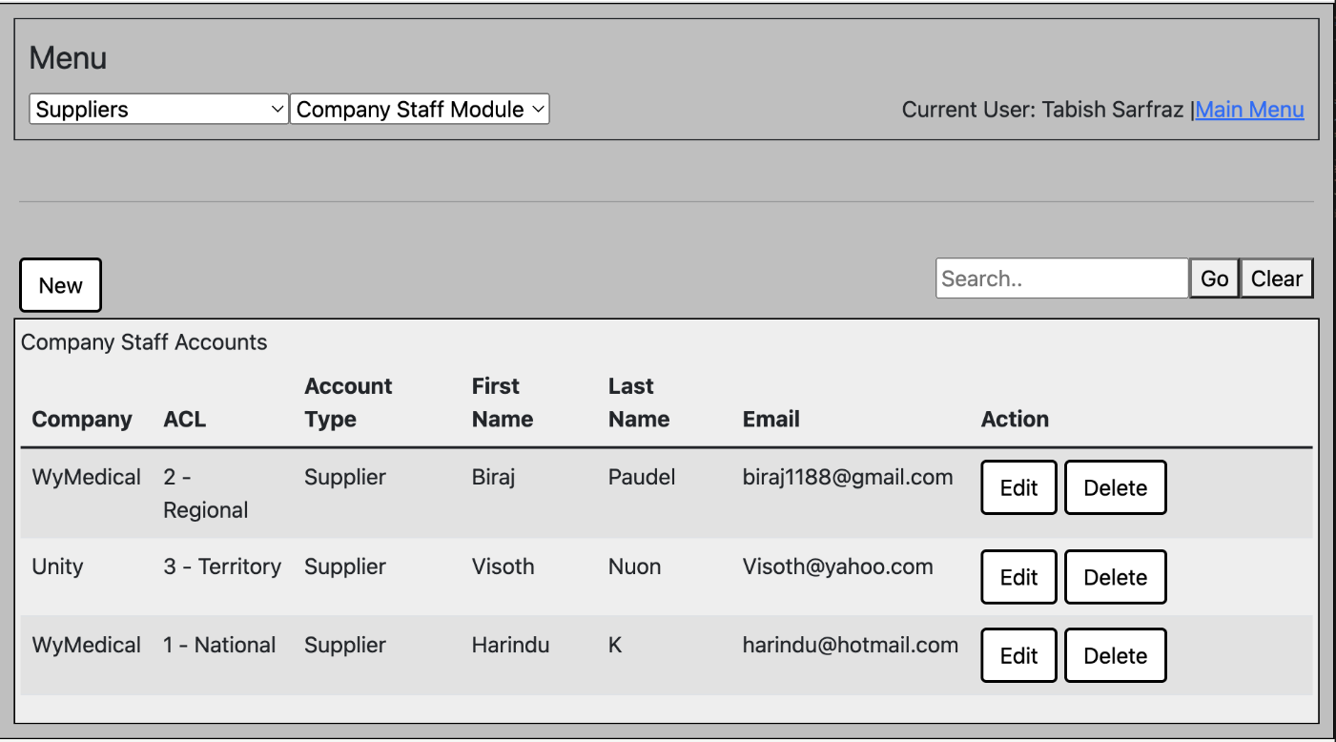

*Fig 1.1: Company Staff Accounts List Page*

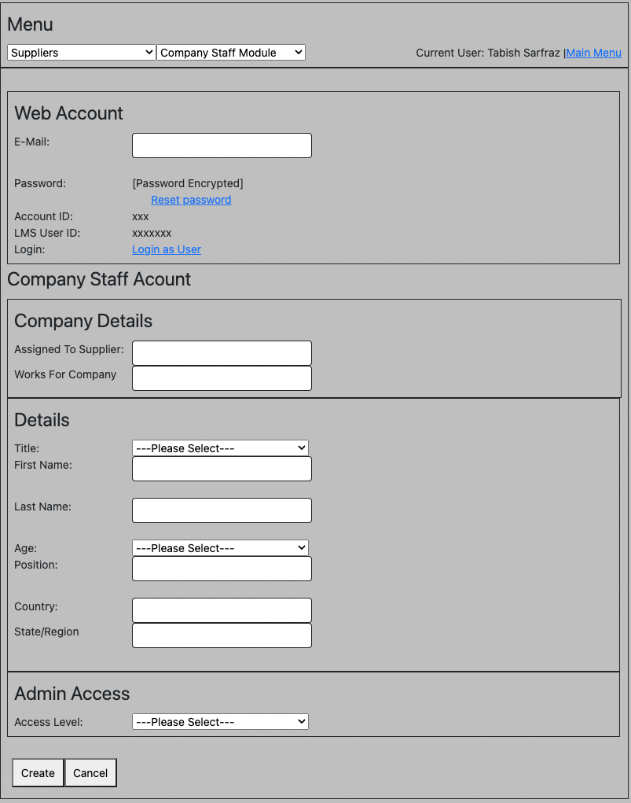

*Fig 1.2: Company Staff Account Form Page*

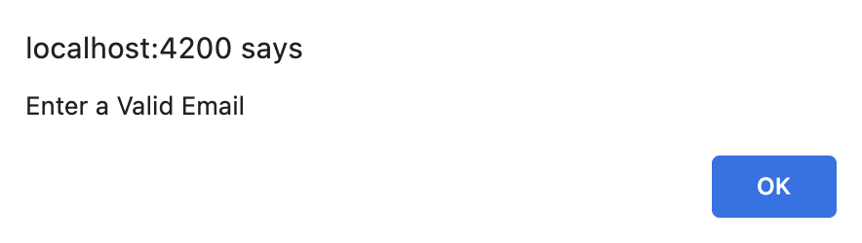

*Fig 1.3: Email Validation Alert*

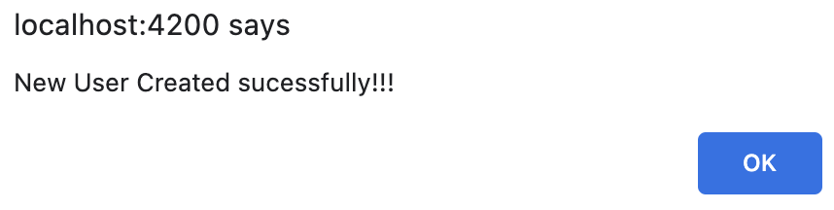

*Fig 1.4: New User Creation Alert*

Figure 1.1 and 1.2 shows the work that we have done in Company Staff Accounts Module of our project. Figure 1.1 is the list page of Company Staff Accounts Module where all the information of a company user is such as name, email, company, account type, access level (ACL) etc., are listed. We have added search, new, edit and delete functionality in the list page. The search functionality works on search by name basis, if we put “bir” in the search bar and hit go, any user with their name containing “bir” will be shown. The delete functionality when clicked will give an alert saying, “Are you sure you want to delete this user?” and when selected yes, the selected users is deleted from the database and the list page gives an alert like fig 1.4 but saying “User deleted successfully!!!”.

The new and edit functionality takes the us to the form pages to create a new user or edit the selected user respectively. The creation from page is shown in fig 1.2 and the edit form page is similar to fig 1.2 but has update button instead of create button. The form page has different field and each fields have validation. If we enter a wrong email to the email field and hit the create or update button, an alert will pop-up as shown in fig 1.3. Similar alerts will pop-up if other fields are filled with wrong information.

There are different drop-down menus in the new and edit form page, the value of the drop-down menus is extracted from the database which make adding in or removing from the drop-down menus easier in the future. Lastly, when a new user is created, an alert as shown in fig 1.4 will pop-up and when the user is updated, similar alert will pop-up but saying “User Updated Successfully!!!”.

Banner Rotator Maintenance Module:

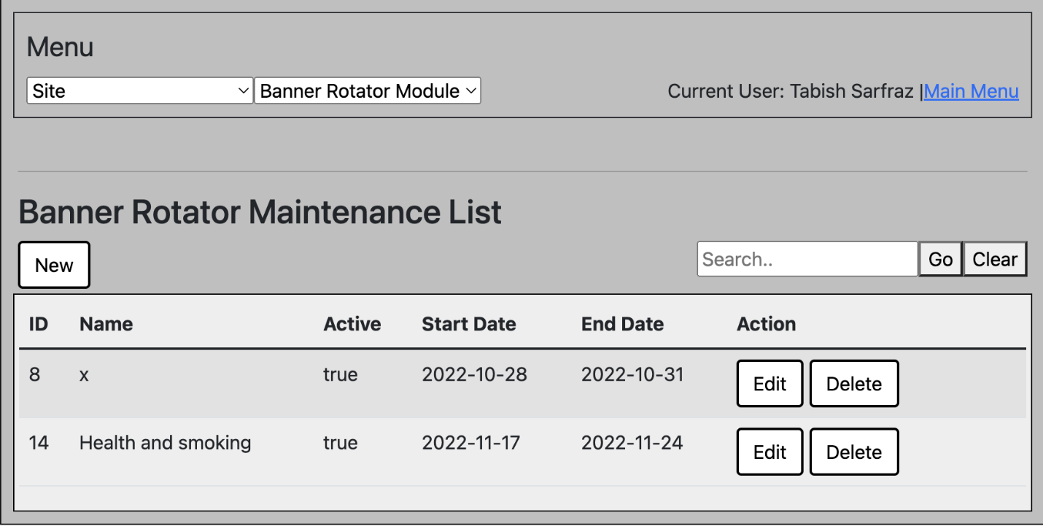

*Fig 2.1: Banner Rotator Maintenance List Page*

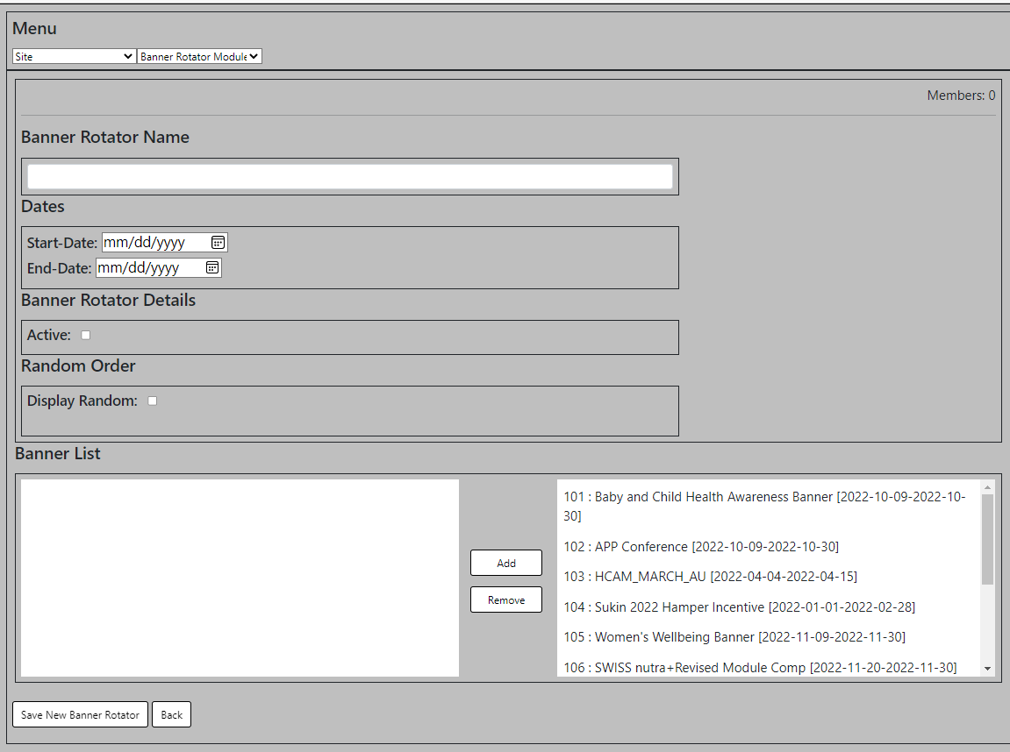

*Fig 2.2: Banner Rotator Maintenance Form Page*

Fig 2.1 and 2.2 shows the work that we have done in Banner Rotator Maintenance Module. Like Company Staff Accounts Module, it also has a list and form page with the list page having similar functionality such as search, new, edit and delete. The list page displays the banner rotator name, active status, start and end date of the banner rotator. It also has similar alerts for the delete as of company staff module.

When clicked on new or edit, banner rotator form page, shown if fig 2.2 is loaded. While creating a banner rotator, we can give it a name, active status, start and end date and choose the banners that it’s going to contain inside of it. The banners and the banner rotator have many to many relationships which is solved by a joining table and whenever a banner rotator is created with banners on it, the id of the banner rotator and the id of all the banners inside of the banner rotator is populated in the joining table. Similarly, we can edit the banner rotator, and remove or add banners to it, change the dates, name or active status using the edit form with similar to banner rotator maintenance form page shown in fig 2.2.

The banners listed in fig 2.2 is from banner table which can be added to or removed from a banner rotator while creating or editing the banner rotator.

We have added validations and alerts to the Banner Rotator Maintenance Module as well. If we try to enter a start date for banner rotator which is before the date of creation of the banner rotator then, an alert pops-up similar to fig 1.3 but saying “Enter a valid start date”. And when a banner rotator is created or updated, pop-up similar to fig 1.4 shows but saying “New Banner Rotator Created Successfully!” and “Banner Rotator Updated Successfully!” respectively.

Research Artifacts for Migration:

This product was supposed to be migrations of previously developed module from Angular 11 to Angular 13. We were given the previous code to work on, but the code was corrupted and missing files and after spending two weeks on it, we discussed with clients and decided to work on research document on how to migrate from Angular 11 to Angular 13. So, we have prepared a research document on how to migrate from Angular 11 to Angular 13.

# Lessons Learned and Recommendations

## **Lessons Learned**

Problem Solving and Technical Skills

* Developed technical skills for Spring boot framework, SQL, Bootstrap, JavaScript, and GitHub.
* Improve problem-solving and manage tasks of the project by discussing with each member of the group.

Interpersonal Skills

* Improved written communication skills through report writing and formatting
* Improved presentation skills

Professional Skills

* Proper time management is necessary to complete project in given timeframe.
* Meeting frequently with team members made it easier to optimize the flow of information.
* Learned project management experience working in a team with industry partners.
* Collaboration with team member

## **Recommendations**

* Processing the project is broken into a series of two-week sprints as agile methodology is improved the project predictability with better control over the project due to deliverables performance tasks to each group member.
* Group meetings more often will help to improve communication skills and improve benefit progress of the project.
* Responsible for group members and helping each other to increase creativity.
* Keep updating and ask for feedback from supervisors.

# Conclusion

This Report provided a completed project for Unity Health iTherapeutics Advanced Admin Tools with the description of processes of the project that provided a background of the project and justification with the requirement to apply objective to the process of the project with scopes processes the project from planned minimum viable products, changed scopes, to final minimum viable products of the project had been done. In addition, this report provides lessons learned and recommendations during the processes of the project.

# Appendix A: Product Breakdown Structure

This is the final product breakdown structure of the completed project for UnityHealth iTherapeutics Advanced Admin Tools.

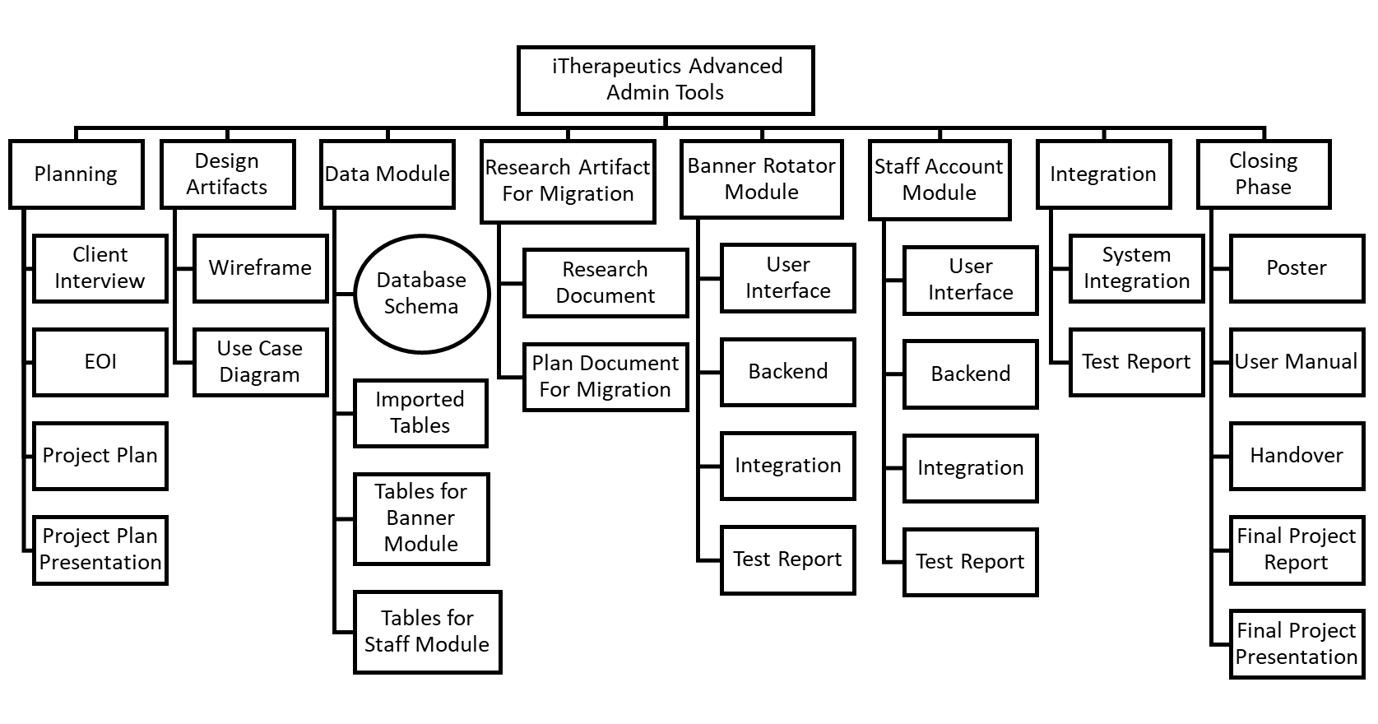

# Appendix B: Context Diagram and Use case Diagram

## **Context Diagram**

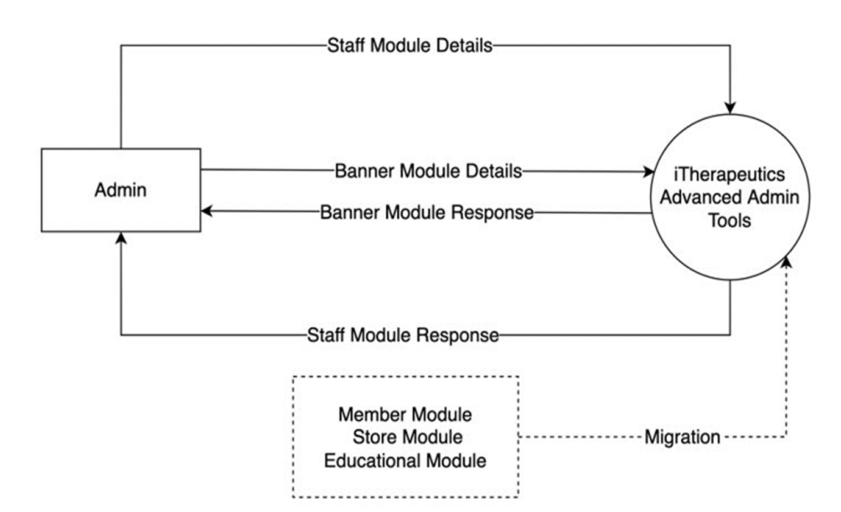

## **Use case Diagram: Company Staff Maintenance Module**

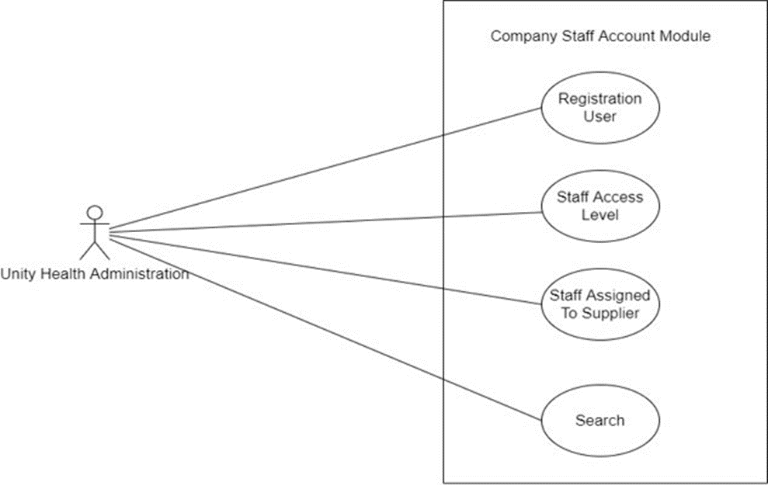

## **Use case Diagram: Banner Rotator Maintenance Module**

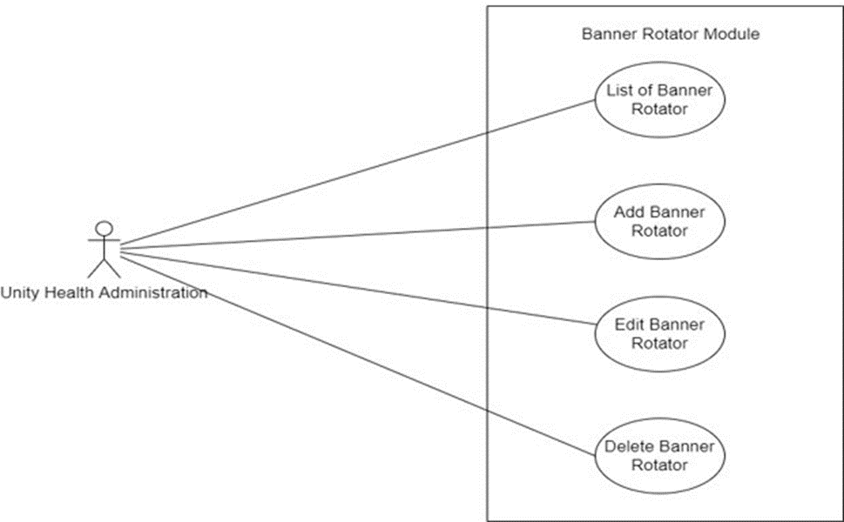

# Appendix C: Project on a page – Unity Health iTherapeutics Advanced Admin Tools

|  |  |  |  |
| --- | --- | --- | --- |
| **Description and Scope**  Unity Health (UH) is an independent health information, education, and technology consulting services company, specialising in Integrative Medicine. The iTherapeutics admin system allows internal staff to maintain several components of the websites. They are facing issue due to the number of languages used and obsolete coding practices involved in develop the admin tools.  There is a need of a system with modern framework to overcome these issues to utilise and improve the efficiency of these admin tools.  **Scope**  The following items are part of the scope for this project is to design and develop Company staff account and  Banner rotator maintenance module and integrate them together for better functionality. |  | **Sprint Details**  **Sprint 1:**   * Development Environment setup * Database schema   **Sprint 2:**   * Research artifact   **Sprint 3:**   * Company Staff Account maintenance module   **Sprint 4**   * Banner rotator maintenance module   **Sprint 5**   * Company Staff Account and banner Rotator Integration * Test Report |  |
| **Project Objectives**  The key objectives for this project:  · Enhanced platform to better integration with modern technologies  · Flexible compatibility with other systems for easy modifications in the future  · Improved user interface for better productive environment  · Increased system security due to the modern technologies | **Resources**  Project Team Member:  Sarnvisoth NUON, Harindu Kalupahana Yasadhara, Biraj Paudel  Software resources:  Java, Angular, Spring boot  MySQL DBMS, XAMPP or WAMP  Visual Paradigm, Visual Studio Code  Communication and document sharing tools: MS Teams, Zoom, GitHub, WhatsApp |  |
| **Key Stakeholders**  *Client*  Nipuna Ranasinghe (Full Stack developer- UnityHealth)  Peter De Lorenzo (CEO of UnityHealth)    *Other*  Project Supervisor: Dr. Sitalakshmi Venkatraman  Project Supervisor: Kiran Fahd  Project Coordinator: Dr. Xiaodong Wang |  |

# Biographies

Biraj Paudel is an international student studying Bachelor of Information technology in Melbourne Polytechnic. He has completed his high school back in his home county I.e., Nepal from V.S Niketan School. He has experience with programming languages such as Java, Ruby, JavaScript's etc. His hobbies include cycling, cooking, and reading and currently works part time as a chef in “The Boat Builders Yard.”

Sarnvisoth Nuon is an international student, currently studying at Melbourne Polytechnic on software development bachelor's degree which will be complete by the end of 2022. He has done his first year of software development bachelor's degree in Cambodia and continued to study in Australia. He has been created a student enrolment system and some mobile applications. He is interested on JavaScript, Python, and Flutter/Dart coding language. He had worked for Dewey international school in Cambodia as an IT support.

Harindu Kalupahana is an undergraduate studying Bachelor of Information Technology, majoring in software development. He holds a certificate of higher education in software engineering from Staffordshire University, UK. In Experience, He completed an internship of 12 months at Digital Media Solutions, AU in software testing and network administration. He was member of student activity club of APIIT in Sri Lanka and was an organiser at numerous sports and social events. As a former sport captain in his school and previous college, He continues playing athletics as a sport and engages in fitness training. Harindu is family-oriented personnel. During the weekend, he loves to go camping with his best mates or enjoys playing badminton or cricket till late night.